Clinical Information Pack

Clinical Lecturer

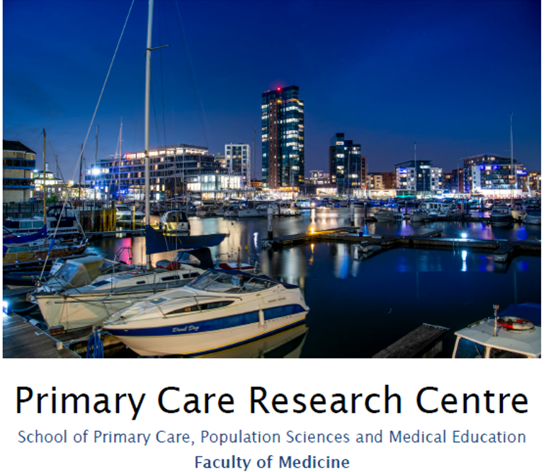

**Particulars of Appointment**

The Faculty of Medicine wishes to appoint an NIHR Academic Clinical Lecturer, hosted by one of three clinical specialties (General Practice based at Aldermoor Health Centre, or Infectious Diseases or Paediatrics based at University Hospital Southampton NHS Foundation Trust).

The post is intended for an applicant within any of these three specialties, with the specialty of the final (single) post dependent on the successful applicant.

The applicant will have a higher research degree (or have submitted for such a degree) and appropriate research experience.

The post is subject to terms and conditions of service determined by the University of Southampton and in its honorary clinical capacity by the University Hospital Southampton Foundation Trust Board.

**This pack sets out the details for the post as it would be linked to General Practice, should this be the specialty of the successful applicant.** The post would be based at the Primary Care Research Centre (**PCRC**), Aldermoor Health Centre, which is one of only nine member departments nationally of the NIHR School for Primary Care Research (**NIHR SPCR**).

The PCRC is part of the School of Primary Care, Population Sciences and Medical Education, within the Faculty of Medicine, and provides an energetic, productive and nurturing research environment. We aim to produce world-leading research, informed by patient and public involvement (**PPIE**), working with health professionals and policy makers and developing research students, to strengthen primary care practice and improve patient outcomes.

PCRC has increased in size, productivity, and influence since 2014, with sufficient critical mass to submit 18 academic staff in the 2021 Universities’ Research Excellence Framework (REF) compared to 13 in REF2014.

**School Information**

**Primary Care, Population Sciences and Medical Education** (PPM) is one of the five Schools in the Faculty of Medicine (Head Professor Julie Parkes). PPM has a single management structure with regular Executive meetings and termly all-staff awaydays, to consider policy, strategy, and research oversight. PCRC is the largest group in PPM, which also contains a Public Health group, Medical Education group, and NIHR Research Design Service (**RDS**) South Central.

The School encompasses a wide range of academic disciplines for applied health research: clinical primary care and public health; epidemiology; medical statistics, qualitative methods, health economics, and health psychology.  There is a single management and administrative structure with bi-monthly team meetings of all senior academic staff, responsible for policy, strategic planning, and research oversight with strategic Away Days.  We have strong research collaborations with relevant clinical disciplines in the Faculty of Medicine and methodologists and clinicians in other Faculties, (notably in Psychology, Medical Sociology, Statistics, Nursing and Health Geography).

The **Primary Care Research Centre (**PCRC) has 10 senior staff (8 professors, 2 associate professors), 4 clinical lecturers, 16 other postdoctoral researchers, and 32 research staff.

PCRC involves public contributors in governance and in all research projects and has an active programme of community engagement. The PPIE steering group includes 4 core public contributors, 2 PPIE officers, senior academics, research manager and research administrator.

Developed to align with national priorities, and designed to facilitate cross-fertilisation and synergy, our five major, overlapping, **themes of research** are:

* **Supporting self-management** addressing increasing needs for self-management of infections, including new viruses, non-communicable long-term conditions, and disability, for an ageing population facing increasing multimorbidity, frailty, and polypharmacy. It builds on our close links with Psychology and international reputation for developing and evaluating digital interventions.
* **Improving use of medicines** including database and observational studies describing medicine use and associated outcomes, qualitative studies of patient and prescriber perspectives, and trials evaluating effectiveness of medicines and optimal use (including deprescribing where appropriate).
* **Healthcare communication** seeking to improve patient outcomes by optimising healthcare interactions, including developing tools to enhance empathy and positive messages, evaluating agenda-setting within consultations, and detailed conversation analysis of video- and audio-recorded consultations to improve communication.
* **Diagnosis and prognosis** including prospective observational studies, routine data studies, qualitative studies, diagnostic studies and randomised trials to improve the management of common conditions in primary care. Ongoing studies focus on diagnosis and prognosis of COVID-19, sore throat, urinary tract infection (UTI), asthma and chronic obstructive pulmonary disease (COPD), mental health problems, atrial fibrillation (AF), and cancer.
* **Data Science:** Uses large volumes of complex, heterogenous, multi-dimensional and often unstructured dataset from different sources with the aim of understanding patterns, trends, and associations of diseases to inform clinical and public health policies and practices. We use traditional statistical methods alongside artificial intelligence algorithms to draw insights on real-world problems.

Cross cutting these themes are our main **clinical areas** of:

* **Infections and antibiotic stewardship**
* **Long-term conditions** (respiratory; mental health; skin; gastrointestinal; musculoskeletal; cancer; cardiovascular etc.)
* **Healthy ageing**
* **Integrative health care**



Our annual research income rose from £2.8M in 2013-14 to £4.8M in 2019-20. Total PPM income over the seven year period was £24.3M (compared to £9.0M for REF2014 over five years), including £21.4M won in open competition from the NIHR and £1.1M from UK research councils. Of 500 grant applications, 187 (37.4%) were successful.

Recent major grants led by CIs at Southampton include:

**10** **NIHR** **PGfAR** **programmes:**

* DIPSS on asthma and hypertension (total *including all partners* £2M);
* CLASP on cancer survivorship (total £2M);
* PRIME on acute respiratory tract infections (RTIs) (£2M);
* ECO on eczema management (£2.7M);
* ACO on acne management (£1.9m)
* REDUCE on antidepressant reduction (£2.4M);
* RECON on cognitive decline (£2.3M);
* STREAM on malnutrition (£2.2M);
* RECUR on recurrent RTIs (£2M).
* AIM on multimorbidity using big data (£2M)

**9 NIHR HTA** **trials:**

* ARTIC-PC for childhood RTIs (£1.2M);
* BREATHE for asthma (£1.5M);
* COAT for cellulitis (£1.48m)
* ACTIB for irritable bowel syndrome (IBS) (£700K);
* BATHE on emollients for eczema (£960K);
* SAFA on spironolactone for acne (£1.7M);
* PROMDEP for assessing depression (£1.6M);
* ATLANTIS on amitriptyline for IBS (£1.7M);
* SupportBack2 on back pain (£1.2M).

In addition we co-lead the £22M PANORAMIC antiviral research platform, and DEFINE FeNO guided asthma care programme, both with Oxford.

There is active use of large databases including CPRD, SAIL, Q-Research, Care and Health Information Exchange Analytics (CHIA) and there is strong methodological input in medical statistics, health economics and qualitative methods.

**Research Students**



Currently we have 7 PPM doctoral students registered in the Faculty, all jointly supervised by two or more academics. In addition, we have 8 students jointly supervised, but registered with other groups (mainly Health Psychology and Health Sciences), arising from our extensive collaborations.

We support and attract research students through:

* Membership of the NIHR School for Primary Care Research, giving access to annually awarded non-clinical PhD studentships and Primary care focussed research training;
* Being one of 10 departments nationally to be awarded Wellcome-funded Clinical PhD fellowships for GP doctorates;
* The Associate Dean for Research’s programme of workshops and individual support for applications for external fellowships including mock interviews;

Our doctoral students undertake individualised learning needs analyses within a month of enrolment and agree tailored training and an annual formal assessment with an adviser outside the supervisory team. PPM provides funding for training and conference attendance and holds a very successful annual PhD presentation conference.

Students receive training and support in PPI, and access to Faculty generic research methods training and pastoral support through programmes run by the Graduate School and Southampton Clinical Academic Training Scheme.

Our doctoral students undertake individualised learning needs analyses within a month of enrolment, and agree tailored training and an annual formal assessment with an adviser outside the supervisory team. PPM provides funding for training and conference attendance and holds a very successful annual PhD presentation conference.

**Primary Care Research Centre – Senior Staff**

Deputy Head of PPM: Professor Hazel Everitt

Deputy Head Research: Professor Nick Francis

Professor Paul Little

Professor Tony Kendrick

Professor Michael Moore

Professor Mike Thomas

Professor Miriam Santer

Professor Geraldine Leydon

Associate Professor Adam Geraghty

Associate Professor Nazrul Islam

Clinical Lecturer: Dr Mark Lown

Clinical Lecturer: Dr Merlin Willcox

NIHR Clinical Lecturer: Dr Hajira Dhamba-Miller

NIHR Clinical Lecturer: Dr Sara McKelvie

Sara McElvie would be very happy to have an informal chat with anyone that was interested in applying, particularly about opportunities for training and mentoring of CLs. Sara was successful with the SPCR TUTOR-PHC Canadian fellowship for 2022-23 and is enrolled on the national NIHR mentoring scheme this year. Also there are opportunities for PGCAP, PPIE and media training in Southampton too. Sara says: *“I’m really glad I’ve joined the department! One of the strengths of the team is that I very quickly felt welcome and valued as a new addition.”*

**The University of Southampton**

The University of Southampton is a leading research-intensive University, a member of the Russell Group and one of the top 100 universities worldwide. We deliver an excellent educational experience, world-leading research and we are known for successfully commercialising that research through enterprise.

This is an exciting time to join the University of Southampton. We have an aspirational University Strategy (see [www.southampton.ac.uk/strategy](http://www.southampton.ac.uk/strategy)), setting out our ambitions over the next five years. The strategy involves achieving a top 10 place in the UK for research, which we will achieve by investing in the highest quality staff and facilities. We are also transforming the education offer available to undergraduate and postgraduate students across the University, providing greater flexibility and modular courses, with a strong international focus.

**The Faculty of Medicine**

Faculty academic staff are organised into PPM and four other research-led Academic Schools:

* Clinical Experimental Sciences
* Human Development and Health
* Cancer Sciences
* School of Healthcare Enterprise and Innovation

Four other research centres are fully integrated with the Faculty and its strategy, all based at the University Hospitals Southampton (**UHS**) main site (see diagram below):

* MRC Lifecourse Epidemiology Unit
* NIHR CRUK Southampton Experimental Cancer Medicine Centre
* NIHR Biomedical Research Centre
* NIHR Southampton Clinical Research Facility

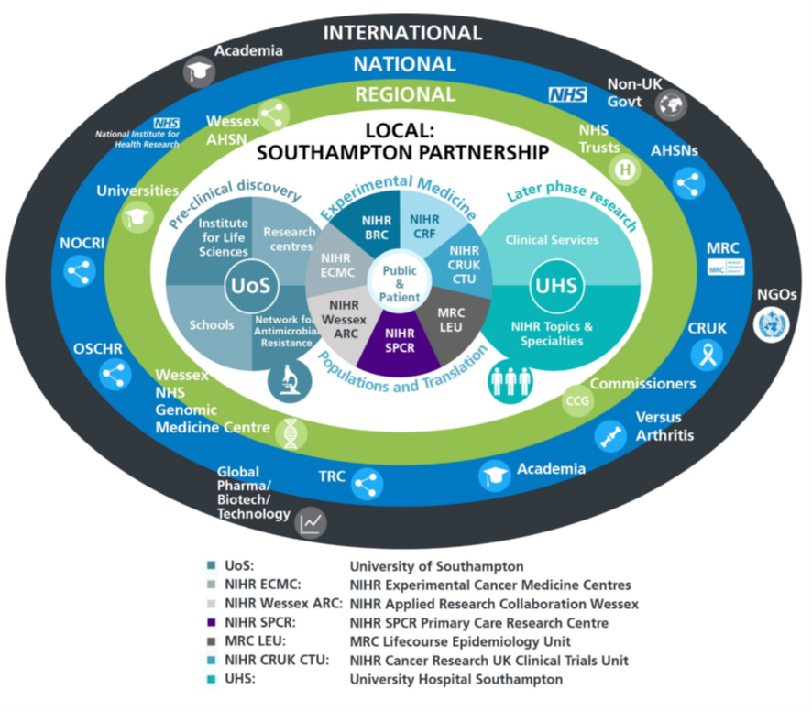

The Faculty celebrated its 50th Anniversary in 2022 and has made a substantial impact across areas of research strength in basic discovery as well as population sciences. The Faculty employs 453 academic staff including 94 professors, 61 associate professors and 35 lecturers. The Faculty is led by the Dean, Professor Diana Eccles. The vision of the Faculty is tolead innovative learning and discovery for better health across the life-course. We have invested in multidisciplinary research teams, creative educational programmes, translational research programmes, clinical infrastructure and enterprise to deliver on this vision. Faculty strategy involves a close partnership with UHS, governed by the Joint Research Strategy Boardjointly chaired by the Dean and Trust Chief Executive. The JRSB leads on strategy, policy and finance related to translational and clinical research across the University and UHS partnership (see diagram above). The Faculty Operating Board meets bi-monthly and comprises the Dean, Heads of Schools; Associate Deans for Research, Education, Enterprise, and Internationalisation; Finance Officer; and Associate Director of Faculty Operations.

**The Student Experience**

We offer a range of undergraduate programmes: the BM4 programme, a graduate-entry four-year programme which accepts 40 students per year; and the BM5and BMedSc programme which accepts 200 students per year including approximately 30 students from a BM6 programme aimed at widening access to a medical career. Science teaching in the first three years of the BM programmes is delivered in the South Block of Southampton General Hospital as well as the Life Sciences Building on Highfield Campus. Clinical teaching takes place at Southampton General Hospital and the adjoining Princess Anne Hospital, the Royal South Hants Hospital, and in NHS Trusts and General Practices throughout Hampshire, Dorset, West Sussex and Salisbury.

The BM5 programme has a number of distinctive features. These include the integrated nature of teaching where the scientific disciplines are taught together in a clinical context using a systems-based approach and the BMedSc programme, an eight-month supervised research project undertaken in Year 4. There is also the opportunity, for selected students, to undertake an integrated, intercalated master’s in medical science (MMedSc). The BM4 programme also has a number of key features. These include clinical topics in the first two years where students meet on a regular basis in Graduate Groups and learning with BM5 students in the third and fourth years on all clinical attachments. All students take the same intermediate and final examinations. All programmes have substantial clinical experience in the first two years, student selected components, dispersed final year attachments, work shadowing prior to commencing a Foundation post and inter-professional learning.

In addition to the undergraduate BM programmes the School provides two master’s degree programmes in Public Health and Allergy.

**Research and Enterprise**

The Faculty of Medicine has a clear research strategy to investigate the biomedical basis of common human diseases and to translate this into clinical practice. All research undertaken within the Faculty has clear evidence of international excellence and is delivered through appropriate Faculty Schools.

The Faculty of Medicine Enterprise Strategy is fully aligned to the University Enterprise Strategy to provide a step change to its enterprise and innovation culture, delivering global outreach, community engagement, innovative healthcare and policy. We work with all stakeholders from industry and pharma to health providers and the community.

**Equality, Diversity and Inclusivity**

We are committed to positively advancing equality of opportunity. We participate in a number of equality initiatives which celebrate good employment practice for the advancement of diversity, equality and inclusivity. These include the Stonewall Workplace Equality Index, the Race Equality Charter and Athena Swan, (for which we are currently silver award holders). We also have a number of staff equality committees who champion the advancement of equalities for diverse groups.

Job Description and Person Specification

|  |  |  |  |  |  |
| --- | --- | --- | --- | --- | --- |
| Post title: | | **NIHR Clinical Lecturer in General Practice** | | | |
| Schools: | | Primary Care, Population Sciences and Medical Education | | | |
| Faculty: | | Faculty of Medicine (FoM) | | | |
| Career Pathway: | | Clinical | Level: | AMCS | |
| Salary: | | £73,367 | To | £95,104 | |
| Clinical category: | | Balanced portfolio | | | |
| Posts responsible to: | | Head of School | | | |
| Posts responsible for: | | Research Staff and Postgraduate Research Students as appropriate | | | |
| Job purpose | | | | | |
| To undertake research in accordance with specific research projects under supervision (up to 0.8fte) and to work as a General Practitioner (up to 0.2fte). | | | | | |
| Key Research accountabilities | | | | | % Time |
|  | |  | | --- | | To develop and carry out an area of personal research. | | To disseminate findings in peer-reviewed journals, present results at conferences or exhibit work at appropriate events. | | To contribute to the writing of bids for research funding. | | Carry out administrative tasks associated with specified research funding, for example risk assessment of research activities, organisation of project meetings and documentation. Implementation of procedures required to ensure accurate and timely formal reporting and financial control. | | | | | 65% |
|  | Key Education accountabilities | | | |  |
|  | |  | | --- | | As a member of a teaching team within an established programme of study, support the teaching objectives of the School/PCRC by delivering teaching to students at undergraduate and/or postgraduate level, through allocated lectures, tutorials, practicals and seminars. | | Directly supervise students, providing advice on study skills and helping with learning problems. Identify the learning needs of students and define learning objectives. Set and mark coursework and exams, providing constructive feedback to students. |  |  | | --- | | Develop own teaching materials, methods and approaches, with guidance. Obtain and analyse feedback on own teaching design and delivery to facilitate this. | | Continually update own knowledge and understanding of subject area, incorporating knowledge of advances into own teaching contributions. | | | | | 10% |
|  | Key Management, Leadership and Engagement accountabilities | | | |  |
|  | Contribute to the efficient management and administration of the School/PCRC by performing personal administrative duties as allocated by the Deputy Head of PPM. | | | | 5% |
| Key Clinical accountabilities | | | | | % Time |
| GP Clinical Lecturers are responsible for arranging their own clinical work in a practice of their choosing. | | | | | 20% |

| Internal and External Relationships |
| --- |
| May have additional reporting and liaison responsibilities to external funding bodies or sponsors.  Collaborators/colleagues in other work areas and institutions. |
| Staff Benefits |
| Working at the University of Southampton gives you access to a wide range of benefits in addition to our competitive rates of pay. Our core benefits include pension scheme membership; a generous annual leave allowance (supplemented by University closure days and public holidays) and excellent family leave arrangements (including maternity, paternity, adoption and parental leave).   * Faculty Mentoring Scheme; * Ability to remain in NHS pension scheme, subject to qualifying criteria; * Discounted Sport and Wellbeing membership; * Access to private dental and/or healthcare insurance; * Cycle to work scheme * Tax-Free childcare |

**Person Specification**

|  |  |  |  |
| --- | --- | --- | --- |
| Criteria | Essential | Desirable | How to be assessed |
| Qualifications, knowledge and experience | Medical degree  GMC registration  MRCGP  Evidence of completion of General Practice training  Evidence of commitment to a clinical academic career  Evidence of ability to undertake statistical analysis  Competence in use of statistical analysis software  Completed PhD or currently registered for PhD with thesis submitted  Experience of undergraduate/postgraduate medical teaching  Experience of undergraduate/postgraduate medical teaching | Experience in conducting a systematic review  Experience in a clinical trial in the community  Experience in developing a complex intervention, e.g digital interventions  Experience in qualitative research | CV/interview |
| Planning and organising | Ability to organise own research activities to deadlines and standards |  | CV/Interview |
| Problem solving and initiative | Ability to develop understanding of complex problems and apply in-depth knowledge to address them |  | CV/interview |
| Management and teamwork | Work effectively in a team, understanding strengths and weaknesses of others | Ability to work in a multi-professional team | CV/interview |
| Communicating and influencing | Communicating new and complex information effectively, both verbally and in writing, engaging the interest and enthusiasm of the target audience  Ability to present research results at group meetings and conferences  Track record of original publications in leading peer-reviewed journals  Work proactively with colleagues in other work areas/institutions, contributing specialist knowledge to achieve outcomes | National/ international research award(s) | CV/interview |
| Other skills and behaviours | Positive attitude to colleagues and students. |  | CV/interview |
| Special requirements | Able to attend national and international conferences to present research results | Experience of presenting at national and international conferences | CV/interview |

**JOB HAZARD ANALYSIS**

**Is this an office-based post?**

|  |  |
| --- | --- |
| Yes | If this post is an office-based job with routine office hazards (eg: use of VDU), no further information needs to be supplied. Do not complete the section below. |
| No | If this post is not office-based or has some hazards other than routine office (eg: more than use of VDU) please complete the analysis below.  Hiring managers are asked to complete this section as accurately as possible to ensure the safety of the post-holder. |

## - HR will send a full PEHQ to all applicants for this position. Please note, if full health clearance is required for a role, this will apply to all individuals, including existing members of staff.

|  |  |  |  |
| --- | --- | --- | --- |
| **ENVIRONMENTAL EXPOSURES** | **Occasionally**  (<30% of time) | **Frequently**  (30-60% of time) | **Constantly**  (> 60% of time) |
| Outside work |  |  |  |
| Extremes of temperature (eg: fridge/ furnace) |  |  |  |
| ## Potential for exposure to body fluids | √ |  |  |
| ## Noise (greater than 80 dba - 8 hrs twa) |  |  |  |
| ## Exposure to hazardous substances (eg: solvents, liquids, dust, fumes, biohazards). Specify below: |  |  |  |
| Frequent hand washing |  |  |  |
| Ionising radiation |  |  |  |
| **EQUIPMENT/TOOLS/MACHINES USED** | | | |
| ## Food handling |  |  |  |
| ## Driving university vehicles(eg: car/van/LGV/PCV) |  |  |  |
| ## Use of latex gloves (prohibited unless specific clinical necessity) | √ |  |  |
| ## Vibrating tools (eg: strimmers, hammer drill, lawnmowers) |  |  |  |
| **PHYSICAL ABILITIES** | | | |
| Load manual handling |  |  |  |
| Repetitive crouching/kneeling/stooping |  |  |  |
| Repetitive pulling/pushing |  |  |  |
| Repetitive lifting |  |  |  |
| Standing for prolonged periods |  |  |  |
| Repetitive climbing (ie: steps, stools, ladders, stairs) |  |  |  |
| Fine motor grips (eg: pipetting) |  |  |  |
| Gross motor grips |  |  |  |
| Repetitive reaching below shoulder height |  |  |  |
| Repetitive reaching at shoulder height |  |  |  |
| Repetitive reaching above shoulder height |  |  |  |
| **PSYCHOSOCIAL ISSUES** | | | |
| Face to face contact with public | √ |  |  |
| Lone working | √ |  |  |
| ## Shift work/night work/on call duties |  |  |  |