Clinical Information Pack
Clinical Lecturer

Post title: | Clinical Lecturer in Infectious Diseases
School: | Clinical and Experimental Sciences
Faculty: | Faculty of Medicine (FoM)
Career Pathway: | Clinical | Level: | *AMNL or CADT
Salary: AMNL scale | £35,858 |  |  | To | £63,423
Salary: CADT scale | £51,017 (ST3/CT3 to ST5) |  |  | To | £58,398 (ST6 to ST8)
Associated NHS Trust | University Hospital Southampton NHS Foundation Trust (UHS)
Clinical category: | Balanced portfolio
Posts responsible to: | Professor of Infectious Diseases
Posts responsible for: | Research Staff and Postgraduate Research Students as appropriate

*AMNL scale to be used if candidate at or above ST3 on 3 August 2016

CADT scale to be used if candidate below ST3 on 3 August 2016

Particulars of Appointment

The Faculty of Medicine supported by University Hospital Southampton NHS Foundation Trust wishes to appoint Clinical Lecturer in Infectious Diseases.

The post-holder will be pursuing his/her development of research and teaching within the School of Clinical and Experimental Sciences within the Faculty of Medicine, University of Southampton. The post-holder will also have clinical commitments at University Hospital Southampton NHS Foundation Trust that will lead to further clinical skills required for specialist training and leading to full registration within the specialty.

The applicant will have a higher research degree (or have submitted for such a degree) and appropriate research experience.

The post is subject to terms and conditions of service determined by the University of Southampton and in its honorary clinical capacity by the University Hospital Southampton Foundation Trust Board.

The University of Southampton

The University of Southampton is a leading research-intensive University, a member of the Russell Group and one of the top 100 universities worldwide. We deliver an excellent educational experience, world-leading research and we are known for successfully commercialising that research through enterprise.

This is an exciting time to join the University of Southampton. We have an aspirational University Strategy (see www.southampton.ac.uk/strategy), setting out our ambitions over the next five years. The strategy involves achieving a top 10 place in the UK for research, which we will achieve by investing in the highest quality staff and facilities. We are also transforming the education offer available to undergraduate and postgraduate students across the University, providing greater flexibility and modular courses, with a strong international focus.

The Faculty of Medicine

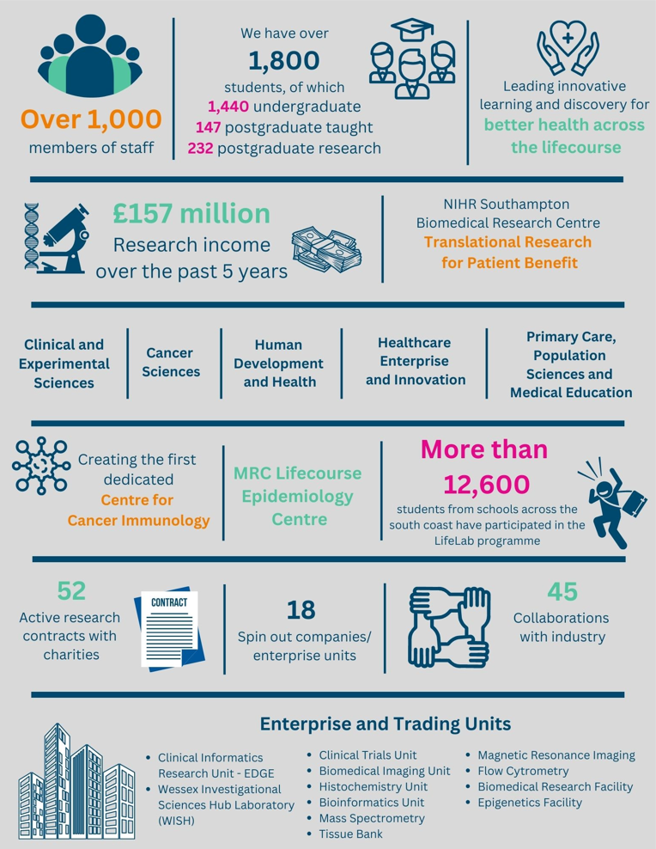

The creation of the Faculty of Medicine has enabled us to build upon strong foundations of basic research and clinical translation. Working with colleagues across the University and in the local NHS we have strengthened our position as a renowned centre for translational research, leading innovative learning and discovery for better health across the life-course. In this context, we are looking to appoint an outstanding senior academic to develop and lead a major programme of funded clinical research in the field of interstitial lung disease.

Key to the success of the Faculty of Medicine is the delivery of high-quality education for undergraduate and postgraduate students, building on our partnership in biomedical research with University Hospital Southampton NHS Foundation Trust and fostering new collaborations with the physical sciences, including chemistry, engineering and computing. The new senior academic in respiratory medicine will play a key role in these developments.

The Faculty celebrated its 40th anniversary in 2016. In 1971 FoM consisted of 40 students. FoM is now reputed for its excellence in research, innovative clinical teaching and is a vibrant pillar of the South of England community

The Student Experience

We offer a range of undergraduate programmes: the BM4 programme, a graduate-entry four-year programme which accepts 48 students per year; and the BM5 and BMedSc programme which accepts 200 students per year including approximately 30 students from a BM6 programme aimed at widening access to a medical career. Students also join the first two years for teaching in Southampton on the BM(EU) Programme, an affiliation with a German Medical school in Kassel. Biomedical/ Psychosocial Teaching in the first two years of the BM programmes is delivered in the South Block of Southampton General Hospital as well as on Highfield campus. Clinical teaching takes place at Southampton General Hospital and the adjoining Princess Anne Hospital, the Royal South Hants Hospital, and in NHS Trusts and General Practices throughout Hampshire, Dorset, West Sussex and Salisbury.

The BM5 programme has a number of distinctive features. These include the integrated nature of teaching where the scientific disciplines are taught together in a clinical context using a systems-based approach and the BMedSc programme, a four-month supervised research project undertaken in Year 3. There is also the opportunity, for selected students, to undertake an integrated, intercalated Masters in Medical Science (MMedSc). The BM4 programme also has several key features. These include clinical topics in the first two years where students meet on a regular basis in Graduate Groups and learning with BM5 students in the third and fourth years on all clinical attachments. All students take the same final examinations. All programmes have substantial clinical experience in the first two years, student selected components, dispersed final year attachments, work shadowing prior to commencing a Foundation post and inter-professional learning.

In addition to the undergraduate BM programmes the School provides four Masters Degree programmes in Public Health, Allergy, Genomics and Diabetes plus an MRres.

Research and Enterprise

The Faculty of Medicine has a clear research strategy to investigate the biomedical basis of common human diseases and to translate this into clinical practice. All research undertaken within the Faculty has clear evidence of international excellence and is delivered through appropriate Faculty Schools.

The Faculty of Medicine Enterprise Strategy is fully aligned to the University Enterprise Strategy to provide a step change to its enterprise and innovation culture, delivering global outreach, community engagement, innovative healthcare and policy. We work with all stakeholders from industry and pharma to health providers and the community.

Equality, Diversity and Inclusivity

We are committed to positively advancing equality of opportunity. We participate in a number of equality initiatives which celebrate good employment practice for the advancement of diversity, equality and inclusivity. These include the Stonewall Workplace Equality Index, the Race Equality Charter and Athena Swan, (for which we are currently silver award holders). We also have a number of staff equality committees who champion the advancement of equalities for diverse groups.



Southampton Behaviours

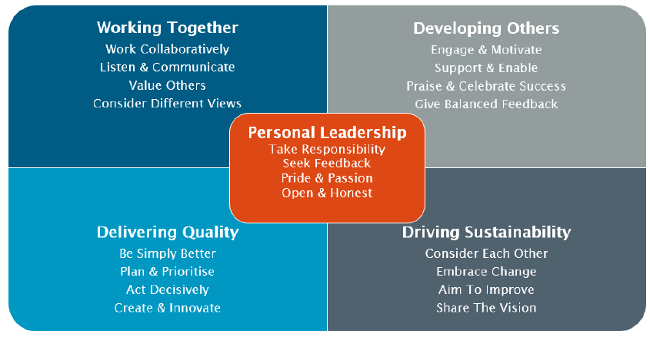

School Information –

Clinical and Experimental Sciences (CES)

Research within CES spans numerous clinical areas, including major human infectious diseases and diseases that affect the central nervous system, eyes, GI tract, joints, liver, lungs, skin and urogenital tract. We focus on important common chronic inflammatory conditions such as age-related macular degeneration (AMD), allergy, asthma, chronic obstructive pulmonary disease (COPD), Crohn's disease, psoriasis, rheumatoid arthritis, psychiatric illness including affective disorders, alcohol dependence, psychosis, and neurodegenerative ageing conditions such as Alzheimer's disease and glaucoma.

Our key strengths include our ability to exploit cross-cutting themes and to study disease mechanisms from the molecular level to the whole patient. We conduct clinical trials, with both commercial and non-commercial partners, where insights from basic science in the laboratory are now underpinning novel treatments, gene therapies and stem cell research. We value cross-disciplinary and industrial collaborations that promote ‘joined-up thinking' to support and accelerate our research progress, through access to novel expertise and technologies.

Our researchers work in partnership with local NHS Trusts (e.g. through our NIHR-funded Respiratory Biomedical Research Centre and play leading roles in national and international consortia such as the MRC/ABPI COPD initiative and the joint EU/EFPIA Innovative Medicines Initiative (UBIOPRED) to maximize our research opportunities. Our diverse group of researchers works with government to help shape Health Policy. Examples of this range from providing expert opinion to the National Institute of Clinical Excellence and the Joint Committee on Vaccination and Immunisation to various Health Select Committees.

Infectious Diseases at Southampton

This is a group publishing world leading research and one which hosts a major research theme of Microbiology Immunology and Infection, Microbiology, Immunology and Infection | Southampton BRC (nihr.ac.uk) within the NIHR Southampton Biomedical Research Centre. The major research areas are; vaccine development and evaluation, human controlled infection research, clinical evaluation of point-of-care diagnostics for infection, tuberculosis, microbiome research and biofilm research.

Staff linked to this post include:

Key Individuals who conduct clinical research in ID/Microbiology
Professor Robert Read, Chair of Infectious Diseases (Professor Robert Read | University of Southampton)
Professor Tristan Clark, Professor of Infectious Diseases (Professor Tristan Clark | University of Southampton)
Professor Saul Faust, Professor of Paediatric Infectious Diseases
Professor Paul Elkington, Professor of Respiratory Medicine
Dr Adam Dale, NIHR Clinical Lecturer in Infectious Diseases and Clinical Microbiology
Dr Nathan Brendish, NIHR Clinical Lecturer in Infectious Diseases and Internal Medicine

The successful candidate will conduct research work in association with one or more of these senior staff members.

University Hospital Southampton NHS Foundation Trust (UHS)

University Hospital Southampton NHS Foundation Trust provides services to some 1.9 million people living in Southampton and south Hampshire, plus specialist services such as neurosciences, cardiac services and children's intensive care to more than 3.7 million people in central southern England and the Channel Islands.
The Trust is also a major centre for teaching and research in association with the University of Southampton and partners including the Medical Research Council and Wellcome Trust.
UHS gained Foundation Trust status on 1 October 2011.
Every year 11,500 UHS staff:
- treat around 150,000 inpatients and day patients, including about 50,000 emergency admissions;
- see over 624,000 people at outpatient appointments; and
- deal with around 135,000 cases in there emergency department.
Providing these services costs £1.9 million a day.

Job Description and Person Specification

Job purpose
The post-holder will have clinical commitments in the Department of Infection at University Hospitals Southampton NHS Foundation Trust (UHS), as well as participating in the development of research and teaching within an appropriate research group of the Faculty of Medicine. The post is subject to terms and conditions of service, determined by the University of Southampton and in its honorary clinical capacity by the University Hospitals Southampton NHS Foundation Trust Board.

Key Research accountabilities |  | % Time
 |  | 35%
  To develop and carry out an area of personal research.
  To disseminate findings in peer-reviewed journals, present results at conferences or exhibit work at appropriate events.
  To contribute to the writing of bids for research funding.
  Carry out administrative tasks associated with specified research funding, for example risk assessment of research activities, organisation of project meetings and documentation. Implementation of procedures required to ensure accurate and timely formal reporting and financial control.

 | Key Education accountabilities
 |  | 10%
  As a member of a teaching team within an established programme of study, support the teaching objectives of the School/Department by delivering teaching to students at undergraduate and/or postgraduate level, through allocated lectures, tutorials, practicals and seminars.
  Directly supervise students, providing advice on study skills and helping with learning problems. Identify the learning needs of students and define learning objectives. Set and mark coursework and exams, providing constructive feedback to students.
  Develop own teaching materials, methods and approaches, with guidance. Obtain and analyse feedback on own teaching design and delivery to facilitate this.
  Continually update own knowledge and understanding of subject area, incorporating knowledge of advances into own teaching contributions.

 | Key Management, Leadership and Engagement accountabilities
 | Contribute to the efficient management and administration of the School/Department by performing personal administrative duties as allocated by the Head, e.g. library representative, year tutor, exchange-programme coordinator, etc. | 5%

Key Clinical accountabilities | % Time
This is a clinical training post and the appointed candidate will receive a national training number in Infectious Diseases and General Internal Medicine OR Clinical Microbiology, depending on the career aspirations of the trainee. In line with other NIHR clinical lecturers at least 50% of time will be protected for academic work.  On-call Arrangements  The exact nature of any on-call commitments to be undertaken will be agreed with the Trust within the job plan. | 50%

Internal and External Relationships
Member of the School/Department Board, Examination Board and of such School/Department committees relevant to their administrative duties.

New appointees will be assigned a senior colleague to guide their development and aid their integration into the School/Department and university.

Research priorities will be agreed within the strategic framework of the research theme of which they are a member.

Teaching and administrative duties will be allocated by the Head of School/Department, within the context of the teaching programmes agreed by the School/Department Learning and Teaching Committee.

Other key relationships;
- Research Colleagues;
- Head of School;
- Central University Offices/Professional Services (e.g. Graduate Office, Finance, Research and Innovation services etc.);
- Delivery of research presentations at national/international conferences and meetings;
- Peer review of research outputs for national/international journals.

Staff Benefits
Working at the University of Southampton gives you access to a wide range of benefits in addition to our competitive rates of pay. Our core benefits include pension scheme membership; a generous annual leave allowance (supplemented by University closure days and public holidays) and excellent family leave arrangements (including maternity, paternity, adoption and parental leave).

- Faculty Mentoring Scheme;
- Ability to remain in NHS pension scheme, subject to qualifying criteria;
- Discounted Sport and Wellbeing membership;
- Access to private dental and/or healthcare insurance;
- Cycle to work scheme
- Tax-Free childcare

Person Specification

Criteria | Essential | Desirable | How to be assessed
Qualifications, knowledge and experience | Basic medical degree, MB BS (or equivalent qualifications)  MRCP or equivalent  Full GMC Registration  PhD/MD (or equivalent) in an area relevant to the post to be awarded before commencing post.  Relevant experience in designing and conducting clinical trials  Demonstrable experience in manuscript and publication writing.  Track record of development and delivery of teaching at undergraduate and postgraduate level.  Must demonstrate outstanding potential through success at doctoral research and show further potential for development as a clinical academic in research and/or education research. | Proven track record in grant application and funding.  Clinical experience in Infectious diseases and general internal medicine appropriate for the level of training  Suitable training background to enter a training programme in Infectious Diseases and General Internal Medicine or Clinical Microbiology  A clear appetite for research in infectious diseases and clinical microbiology with a basic notion of research activity to be undertaken | CV/Interview
Planning and organising | Proven ability to plan and develop a range of high-quality research and teaching activities, ensuring plans complement broader research and education strategy.  Able to develop innovative research proposals and attract research funding.  Able to submit applications for ethical approval.  Ability to plan, manage, organise and assess own teaching contributions. |  | CV/Interview
Problem solving and initiative | Ability to use statistical analysis to a competent level to assess issues.  Able to apply originality in modifying existing approaches to solve problems. |  | CV/interview
Management and teamwork | Operational management of research staff and academic groupings.  Ability to manage and deliver course units and team-taught course units.  Able to undertake coordinating role in School/Department/University.  Ability to work effectively in a team and to collaborate with others, including external collaborators |  | CV/interview
Communicating and influencing | Communicate new and complex information, both verbally and in writing, engaging the interest and enthusiasm of the target audience.  Ability to present research findings at local, national and international meetings/conferences.  Able to persuade and influence at all levels in order to foster and maintain relationships, resolving tensions/ difficulties as they arise. |  | Interview
Other skills and behaviours | Understanding of relevant Health & Safety issues.  Positive attitude to colleagues and students. |  | CV
Special requirements | Able to work clinically at the level of a Specialist Register in infectious disease and general internal medicine  Able to attend national and international conferences to present research results. | To be on a Specialist Registrar training programme | CV and interview

JOB HAZARD ANALYSIS

Is this an office-based post?
☐ Yes | If this post is an office-based job with routine office hazards (eg: use of VDU), no further information needs to be supplied. Do not complete the section below.
☒ No | If this post is not office-based or has some hazards other than routine office (eg: more than use of VDU) please complete the analysis below.  Hiring managers are asked to complete this section as accurately as possible to ensure the safety of the post-holder.

## - HR will send a full PEHQ to all applicants for this position. Please note, if full health clearance is required for a role, this will apply to all individuals, including existing members of staff.

ENVIRONMENTAL EXPOSURES | Occasionally  (<30% of time) | Frequently  (30-60% of time) | Constantly  (> 60% of time)
Outside work
Extremes of temperature (eg: fridge/ furnace)
## Potential for exposure to body fluids
## Noise (greater than 80 dba - 8 hrs twa)
## Exposure to hazardous substances (eg: solvents, liquids, dust, fumes, biohazards). Specify below:
Frequent hand washing
Ionising radiation
EQUIPMENT/TOOLS/MACHINES USED
## Food handling
## Driving university vehicles(eg: car/van/LGV/PCV)
## Use of latex gloves (prohibited unless specific clinical necessity)
## Vibrating tools (eg: strimmers, hammer drill, lawnmowers)
PHYSICAL ABILITIES
Load manual handling
Repetitive crouching/kneeling/stooping
Repetitive pulling/pushing
Repetitive lifting
Standing for prolonged periods
Repetitive climbing (ie: steps, stools, ladders, stairs)
Fine motor grips (eg: pipetting)
Gross motor grips
Repetitive reaching below shoulder height
Repetitive reaching at shoulder height
Repetitive reaching above shoulder height
PSYCHOSOCIAL ISSUES
Face to face contact with public
Lone working
## Shift work/night work/on call duties

